Applecross Senior High School
Year 11 Human Biology 2A
Test 2
Section A Multiple Choice (25 marks)

1. The function of blood is/are:

a) transport of oxygen and nutrients
b) regulation of body temperature
c) fighting infection
d) all of the above

2. Most oxygen and carbon dioxide in the blood is carried in the form of:
a) carbonic acid & haemoglobin ion
b) bicarbonate ion & hydrogen ion
c) oxyhaemoglobin & bicarbonate ion
d) haemoglobin ion & water

3. The right ventricle of the heart pumps:

- oxygenated blood to the rest of the body
- deoxygenated blood to the right atrium
- deoxygenated blood to the lungs
- oxygenated blood to the right atrium

4. Which of the following carry exclusively oxygen-rich blood?

a) systemic arteries, systemic veins
b) pulmonary veins, systemic arteries
c) pulmonary arteries, systemic arteries
d) pulmonary arteries, pulmonary veins
5. Which of the following play an important role in the clotting of blood?

a) leucocytes
b) thrombocytes
c) erythrocytes
d) lymphocytes

6. During the cardiac cycle the following events take place:

- atrial systole
- diastole
- ventricular systole

In which order do the events occur?

- atrial systole, diastole, ventricular systole
- diastole, ventricular systole, diastole
- ventricular systole, atrial systole, diastole
d) atrial systole, ventricular systole, diastole

7. Erythrocytes, leucocytes, thrombocytes and plasma are all components of blood. Below is a table illustrating one feature of each – which is CORRECT.

 | erythrocyte | leucocyte | thrombocyte | plasma
(a) | biconcave | granular/agranular | no nuclei | liquid
(b) | biconcave | no nuclei | combats inflammation | contains solutes
(c) | contains haemoglobin | combats inflammation | large comparatively | mostly water
(d) | no nuclei | large comparatively | > numerous than erythrocytes | a formed element
Table 1: Features of Blood

8. The semilunar valves prevent the backflow of blood

a) from the ventricles into the atria.
b) from the arteries into the ventricles.
c) from the atria into the veins.
d) from the atria into the ventricles.

9. Besides excreting harmful and unwanted substances the kidneys also:

a) deaminate proteins.
b) transform glucose nto the polymer glycogen.
c) regulate the fluid content of the blood.
d) manufacture urea.

10. Which of the following describes the pathway of a waste molecule which is excreted by the kidney?

a) Bowman’s capsule → glomerulus → tubule → ureter → bladder
b) glomerulus → Bowman’s capsule → tubule → urethra → bladder
c) Bowman’s capsule → glomerulus → tubule → urethra → bladder
d) glomerulus → Bowman’s capsule → tubule → ureter → bladder

11. Consider the concentration of water in blood of the artery supplying the kidney and in the blood of the vein leading from the kidney.
Which of the following statements is correct?

a) The concentration of water in the blood of the artery supplying the kidney is greater than the concentration of water in the blood of the vein leading from the kidney.
b) The concentration of water in the blood of the artery supplying the kidney is less than the concentration of water in the blood of the vein leading from the kidney.
c) There is no significant difference between the concentration of water in blood of the artery supplying the kidney and in the blood of the vein leading from the kidney.d) It is difficult to measure the concentration of water in blood of the artery supplying the kidney and in the blood of the vein leading from the kidney.

12. When air is inhaled it flows through the air tube system to reach the air sacs.
What order does the air follow?

a) Nasal cavity, Trachea, Bronchi, Pharynx, Bronchioles, Larynx.
b) Nasal cavity, Bronchi, Larynx, Trachea, Pharynx, Bronchioles.
c) Nasal cavity, Pharynx, Larynx, Trachea, Bronchi, Bronchioles.
d) Nasal cavity, Bronchi, Bronchioles, Trachea, Pharynx, Larynx.

13. The rings in the wall of the trachea

a) prevent it collapsing under pressure
b) make it larger
c) prevent it filling with mucus
d) enable air to be forced out of the lungs

14. The function of the fluid secreted by the Pleural membranes is to

a) allow friction free movement of the lungs inside the thoracic cavity
b) expand the volume of the thoracic cavity
c) increase friction between the 2 pleural membranes
d) force the pleural membranes further apart from one another

15. Air enters the lungs during breathing because:

a) there is a vacuum
b) air pressure outside the body is greater than inside the chest (thoracic) cavity
c) the intercostal muscles expand and stretch the lungs
d) the lungs are attached to the diaphragm, which is lowered

16. The functional units of the respiratory system where gas exchange occurs are the:

a) alveoli
b) terminal bronchioles
c) pulmonary vessels
d) lungs

17. . Mucus secreted by the epithelial cells of the trachea

a) lubricates the trachea to facilitate the movement of air into the lungs.
b) moistens the incoming air so that the alveoli do not dry out.
c) traps dust particles in inspired air.
d) warms the incoming air so that core body temperature is not reduced.

18. Contraction of the diaphragm muscle results in

a) a decrease in the volume of the thoracic cavity
- an increase in the volume of thoracic cavity
- expiration
- peristalsis

19. Consider the diagram below.
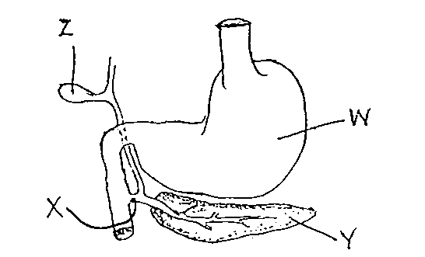

Which of the following pairs of substances pass through structure X?

a) hydrochloric acid and bile.
b) bile and pancreatic juice.
c) salivary amylase and intestinal juice.
d) gastric protease and hydrochloric acid.

20. The function of the villi and microvilli in the small intestine is to:

a) decrease the amount of exposed surface
b) increase the total area of enzyme retention
c) increase the total area for absorption
d) all of the above

21. Which one of the following nutrients, after digestion, could be expected to enter the blood stream via the lymphatic system?

a) starch
b) milk sugar
c) protein
d) fat

22. When passing from the stomach to the duodenum, food must pass through the

a) pyloric sphincter
b) oesophagus
c) bile duct.
d) cardiac sphincter

23. In the large intestine the following nutrients are absorbed.

a) amino acids and fats
b) water
c) carbohydrates and fibre
d) water, some minerals and vitamins

24. The intestinal enzyme that digests protein is:

a) maltase.
b) sucrase.
c) protease.
d) lipase.

25. The most effective and least harmful way of increasing peristalsis in order to prevent constipation is to:

a) eat more foods containing roughage.
b) drink smaller quantities of water.
c) take gentle laxatives.
d) refrain from exercising after meals.

PART B SHORT ANSWER SECTION Name _________________________ 25 MARKS

Complete each of the following questions in the spaces provided.

26. a) There are four organs of the body which are involved in excretion of unwanted substances. Describe each of these by completing the following table. (4 marks)

Excretory organ | Substances excreted

27. Complete the Table below for each type of blood vessel stated, giving (a) one function it serves,
and (b) one structural feature which helps it carry out the function.

Blood Vessel | Function | Structural Feature
1. Artery | (a) | (b)
2. Capillary | (a) | (b)
3. Vein | (a) | (b)
(6 marks)

28. The diagram below shows the digestive system of an adult.
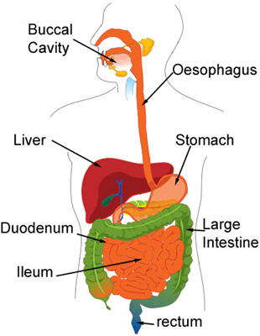
B
C
D
E
F
G
H
A

a) Name the structures labelled in the diagram above. (8 marks)
A ___________________________________ E__________________________________
B ___________________________________ F__________________________________
C ___________________________________ G__________________________________
D ___________________________________ H __________________________________
b) Name the secretion from C used in digestion and describe its role in digestion. (2 marks)
_______________________________________________________________________________
_______________________________________________________________________________

29. The process of respiration involves several processes and structures. Give the correct biological term described by the following.

a) A flap of tissue which, when swallowing, closes off the trachea
so that food and liquid cannot enter the lungs. _____________________
b) The membrane which covers the lungs and lines the inside of
the chest. _____________________

c) Breathing in. _____________________

d) Muscles between the ribs which move the rib cage upwards and
outwards to increase the volume of the lungs. _____________________

e) Gas which diffuses from the blood into the lungs. _____________________
(5 marks)

